**GROUP 5**

**810021205099**

**V.Vijayalakshmi**

**Website Traffic Analysis**

**Project Overview**

The Website Traffic Analysis project aims to assess and understand the patterns, trends, and user behaviour on a specific website. By collecting and analysing data, the project will provide insights into the site's performance, user engagement, and areas for improvement. The results will inform decision-making, helping to optimize the website's content, design, and marketing strategies for enhanced user experience and increased traffic.

**OBJECTIVE**

Equipped with the right website traffic analysis tools, identify your top site pages, track visitor trends, calculate conversion rates, and ensure your marketing spend translates into an increase in conversions and sales.

**1.DATA EXTRACTION:**

**INSTALLATION OF JUPYTER NOTEBOOK**

Command to install jupyter notebook:



Output:



**WORKING OF JUPYTER NOTEBOOK:**

**Command to open jupyter notbook:**



**Output:** 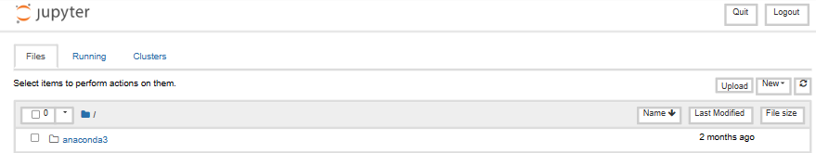

**EXTRACTION:**

Packages needed:

To extract command for those modules:



**Input:**

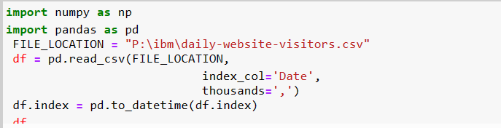

**CODE DESCRIPTION:**

* The code starts by importing the pandas library.
* The code then creates a variable called FILE_LOCATION and assigns it to the path of a file on your computer.
* Next, the code reads in that CSV file into a DataFrame object using read_csv().
* The index column is set to Date, which means that this DataFrame will have one row for each day of data.
* The index_col='Date' parameter specifies that the column with the date should be used as the index.
* The thousands=',' parameter tells pandas to use commas for thousands separators in this column.
* The code opens a file called "P:\ibm\daily-website-visitors.csv" and reads in the data using csv.reader().
* The data is then stored in a list, which is assigned to variable "data".
* Next, numpy is imported as np so that we can use it to analyze the data.
* Finally, the first row of our dataset is analyzed with np.array() and printed out on screen for us to see what's going on with this dataset.
* The code will open the file "P:\ibm\daily-website-visitors.csv" and read the data in as a list of tuples, one for each row of data.

**Output:**

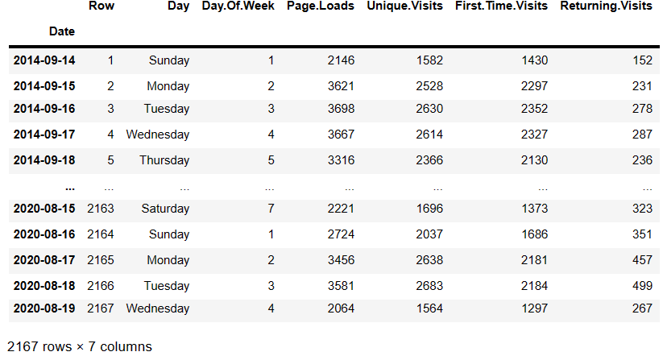

**EXTRACTION WITH VISUALIZATION:**

**Extraction is the process of retrieving or pulling data from one or more sources. These sources can be diverse and include databases, spreadsheets, web services, logs, and more.**

**Transformation involves manipulating, cleaning, and structuring the data to make it suitable for the desired use case. This can include operations like filtering, aggregating, joining, and more.**

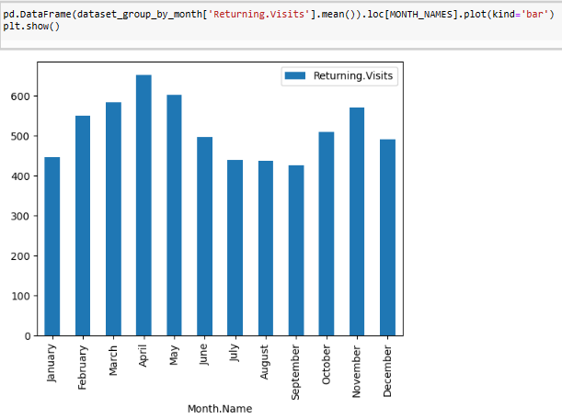

**2.COGNOS ANALYTICS IN ACTION**

Cognos Analytics serves as a powerful tool to transform our analytical findings into actionable insights. This section explores the utilization of Cognos Analytics in enhancing the accessibility and applicability of our results.

**Dashboard Design**

We delve into the process of designing intuitive dashboards within Cognos Analytics. These dashboards serve as a centralized hub for visualizing key metrics, trends, and predictions derived from our analysis.

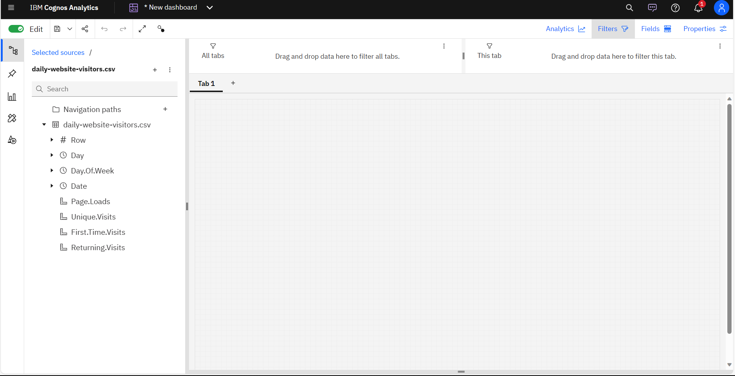

**Report Generation**

Cognos Analytics enables the creation of comprehensive reports summarizing the outcomes of our efficiency analysis. This section outlines the steps involved in generating reports that cater to various stakeholders, providing customized views based on their informational needs.

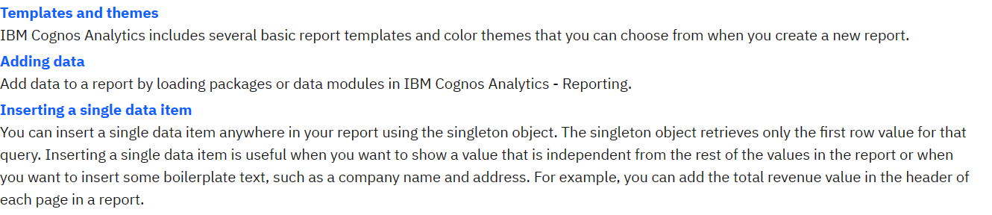

**Continuous Improvement**

In a world where consumer preferences and market dynamics are in constant flux, the ability to adapt and refine sales strategies is paramount. This process begins with the collection of high-quality data, which serves as the foundation for informed decision-making. The art of continuous improvement lies in the willingness to evolve – iterating sales and marketing approaches, fostering cross-functional collaboration, and investing in the growth of sales teams.

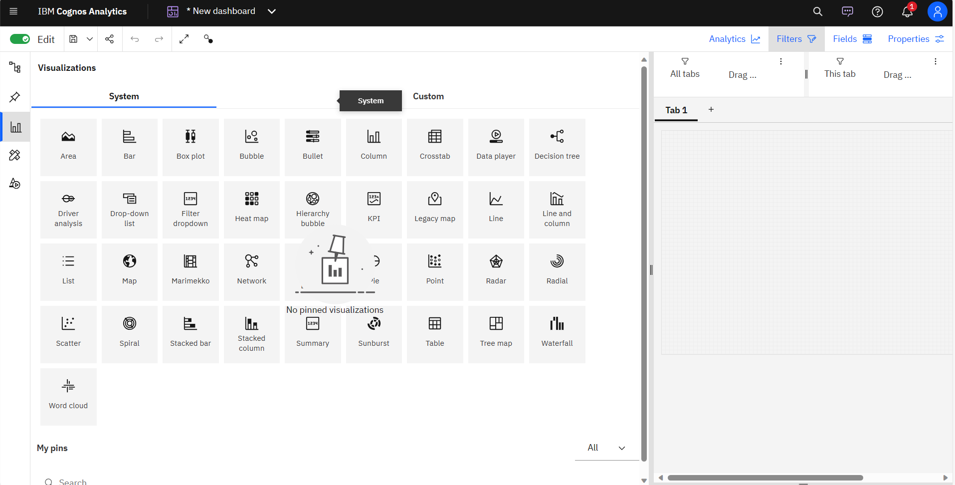

**Actionability**

The practicality of our recommendations was assessed through engagement with stakeholders responsible for implementing changes based on our analysis.

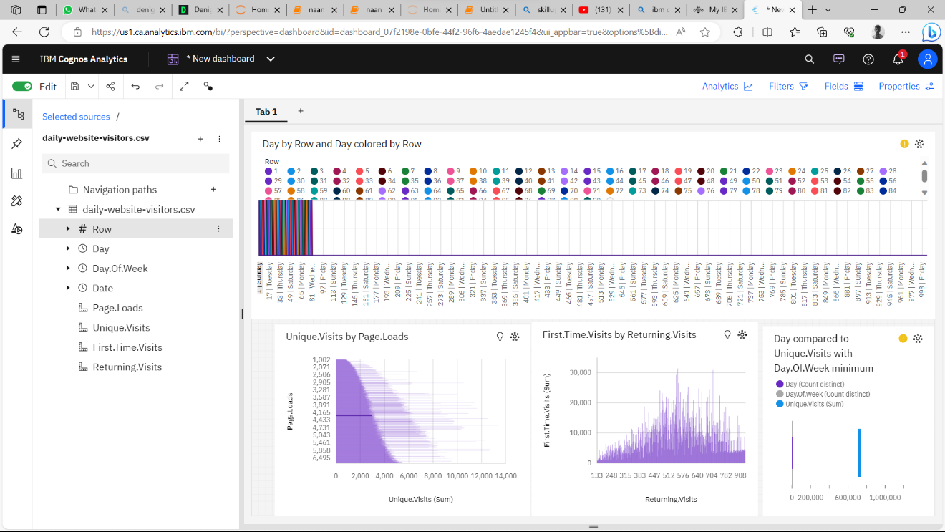

**Conclusion**

Website traffic analysis is the compass that guides the visitors of the websites. It provides critical insights that are fundamental to success. By examining data, inspection can make informed decisions about their usual, regular, unique visitors of the website. This analysis makes the average view of visitors of the website, then by upgrading to new things in the website makes the visitors more conventional and widely used for the future visits in the website.